Burp Suite Web Application Security Analysis
1. Assessment Overview
- Project: IIC Official Website
- Tool: Burp Suite Professional
- Assessment type: Authorized web application security testing
- Target: https://iic-official-website-hazel.vercel.app/
- Assessment date:
- Tester: Sreenivasa Pai
Test Case BS-01: Baseline HTTP Request and Response Review
Objective: Establish the baseline HTTP behavior of the IIC website.
Request details
- Host: iic-official-website-hazel.vercel.app
- Method: GET
- Path: /
- Response status: 200 OK
- Content type: text/html; charset=utf-8
- Server: Vercel
Procedure: Captured the homepage request and inspected its HTTP response headers and HTML content in Burp Suite Professional.
Observations:
- The homepage returned successfully.
- HSTS was present with max-age=63072000; includeSubDomains; preload.
- X-Frame-Options: DENY and CSP frame-ancestors 'none' were present.
- Access-Control-Allow-Origin: * was observed. Its security significance requires further context; this header alone does not establish a vulnerability.
- The HTML referenced JavaScript and CSS assets, including a Supabase-related JavaScript bundle.
Result: Baseline response captured. No vulnerability confirmed by this test.
Evidence: Burp HTTP history screenshot showing the selected request and response.
Next action: Map application navigation and identify the actual API requests generated by the website.
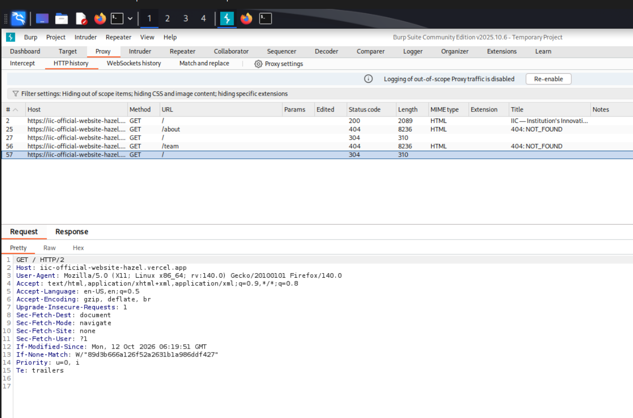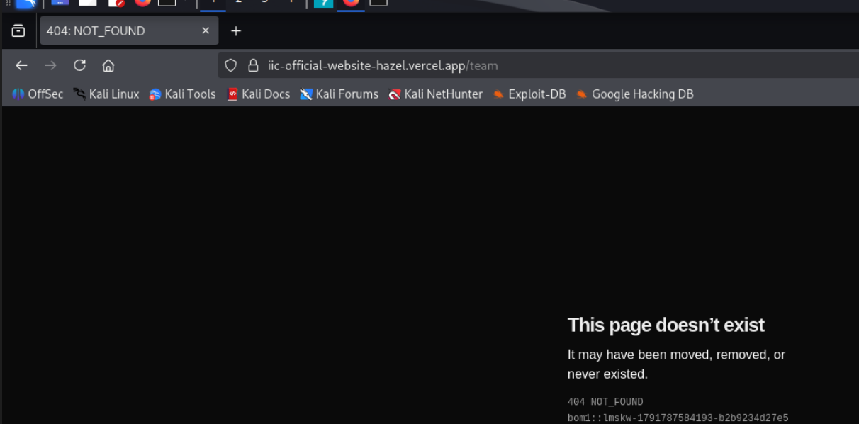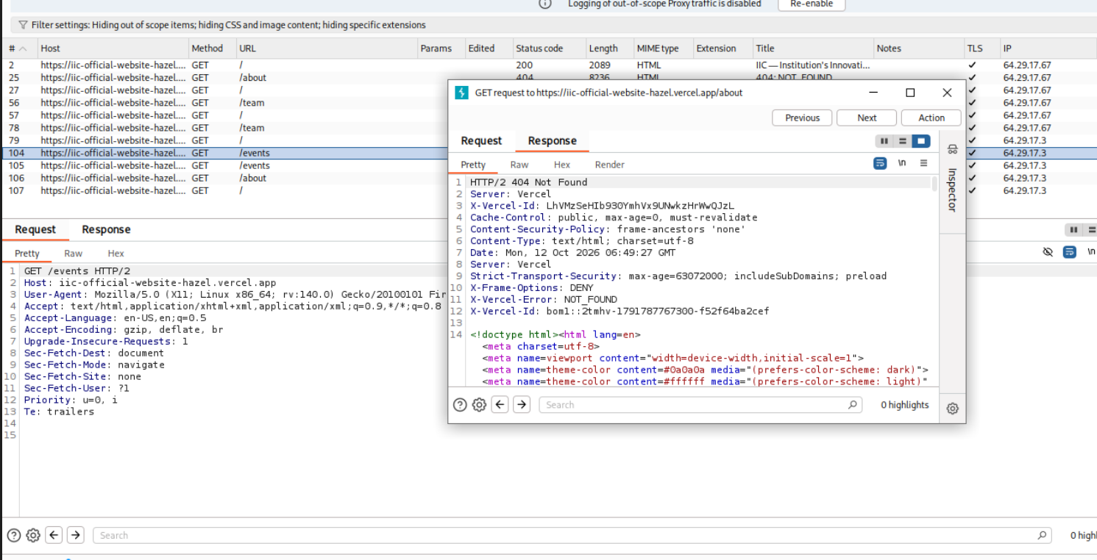
Test Case BS-02: Client-Side Navigation and Direct Route Handling
Objective: Determine whether application routes remain available when directly requested or refreshed.
Tested route: /team
Evidence collected: Burp HTTP history and browser screenshots.
Observed behavior:
- The homepage returned 200 OK.
- The Team page rendered after client-side navigation.
- Direct requests or refreshes to /team returned 404 NOT_FOUND.
- A similar 404 response was observed for /about.
Interpretation: The evidence is consistent with a potential frontend routing or hosting rewrite configuration issue.
Security impact: No direct security impact has been established. The behavior can affect direct links, bookmarks, and usability.
Status: Reproducible behavior observed; root cause not yet confirmed.
Recommended remediation: Review the frontend router and hosting configuration so valid application routes return the SPA entry point, while genuinely unknown routes continue to return 404 responses.

